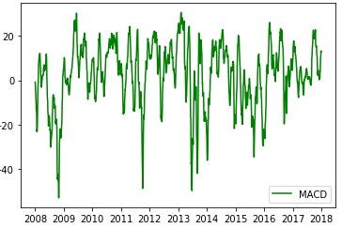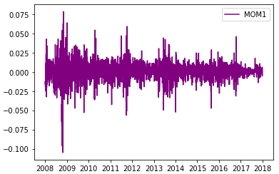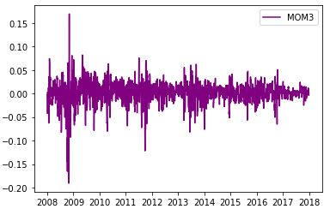

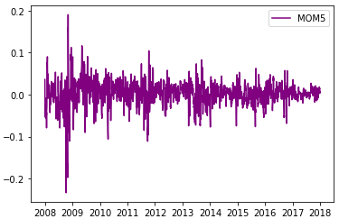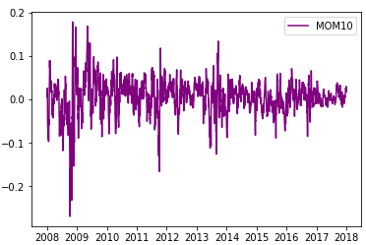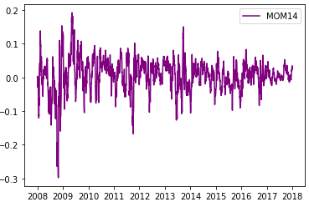

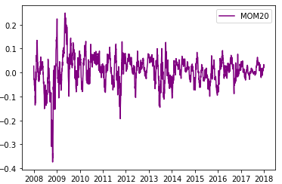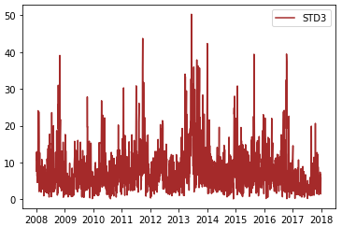 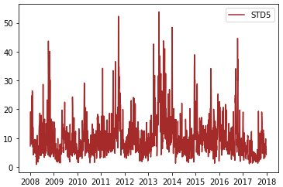

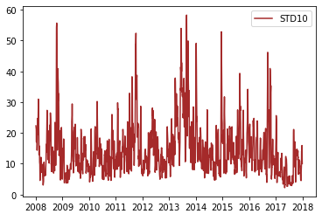 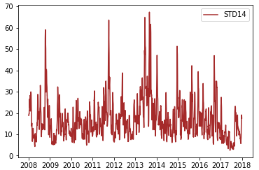 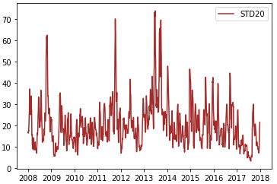

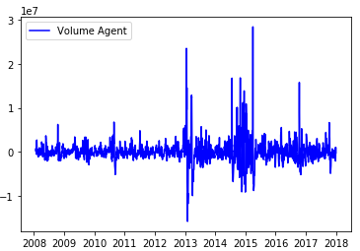

Figure 1: Line Graph on Four Main Technical Indicators in Different Windows of Forecast

|  |  |  |  |
| --- | --- | --- | --- |
| Windows of Forecast | Prediction (-1) | Prediction (0) | Prediction (1) |
| 1 Trading Day  3 Trading Days  5 Trading Days  10 Trading Days  14 Trading Days  20 Trading Days | 604  765  830  846  851  831 | 1117  629  457  302  253  208 | 720  1047  1154  1293  1337  1402 |

Table 1: Distribution of Dependent Variables in Three Classes

|  |  |  |  |  |  |
| --- | --- | --- | --- | --- | --- |
| Descriptive Stat | MACD | MOM_1 | MOM_3 | MOM_5 | MOM_10 |
| Count  Mean  STD  Min  Max | 2441  2.516  14.407  -53.049  30.6 | 2441  0.0004  0.012  -0.105  0.078 | 2441  0.001  0.022  -0.191  0.169 | 2441  0.002  0.029  -0.234  0.191 | 2441  0.004  0.04  -0.27  0.178 |

|  |  |  |  |  |  |
| --- | --- | --- | --- | --- | --- |
| Descriptive Stat | MOM_14 | MOM_20 | STD_3 | STD_5 | STD_10 |
| Count  Mean  STD  Min  Max | 2441  0.005  0.048  -0.3  0.192 | 2441  0.008  0.059  -0.374  0.249 | 2441  8  6.05  0.09  50.28 | 2441  10.363  6.864  0.827  53.864 | 2441  14.607  8.6  2.192  58.287 |

|  |  |  |  |
| --- | --- | --- | --- |
| Descriptive Stat | STD_14 | STD_20 | VOL_AGENT |
| Count  Mean  STD  Min  Max | 2441  17.237  9.55  2.477  67.345 | 2441  20.66  10.8  3.225  74 | 2441  0.463  0.499  0  1 |

Table 2: Descriptive Statistics for Technical Indicator Features

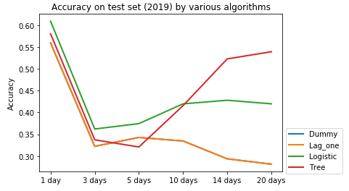

Figure 2: Accuracy on Test Set (2019) by Benchmark Models, Logistic Regression and Decision Tree

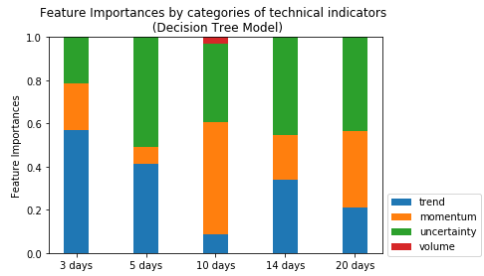

Figure 3: Feature Importances of Each Technical Indicator in Decision Tree Model

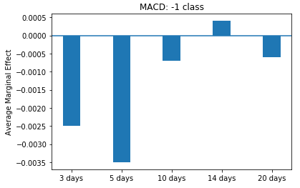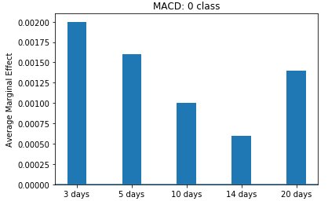

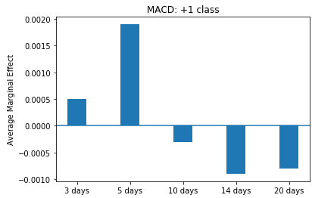 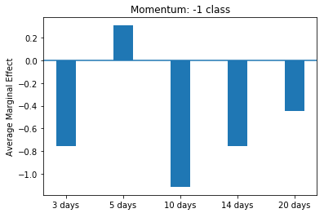

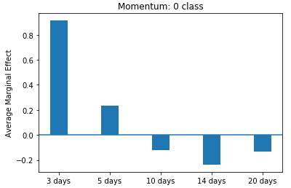 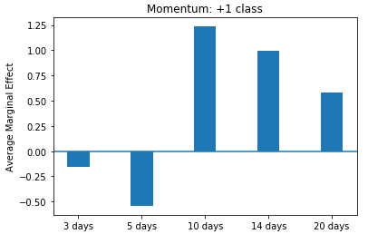

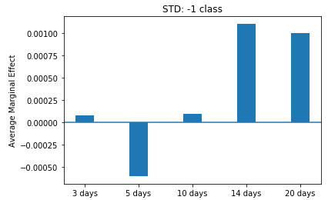 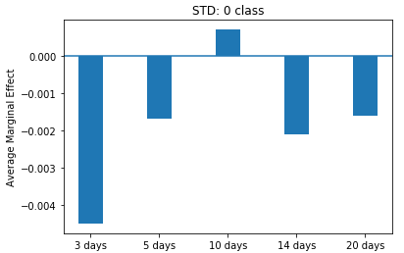

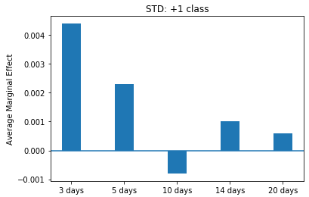 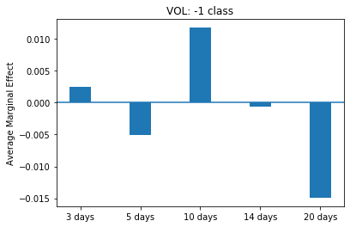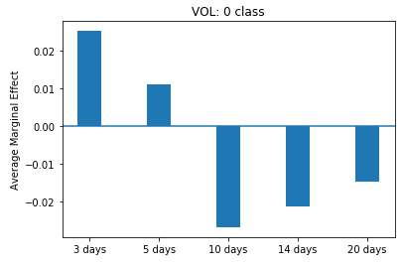 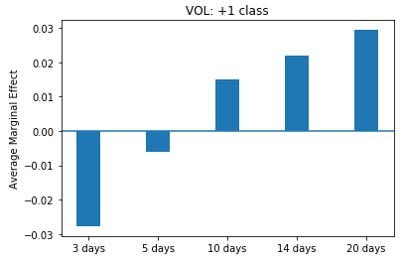

Figure 4: Average Marginal Effect of Each Technical Indicator in Each Class

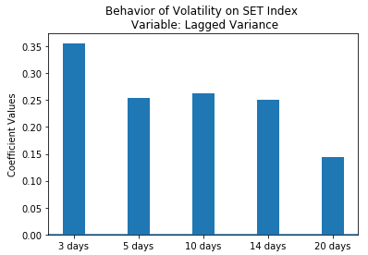 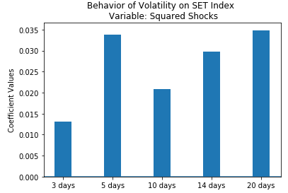

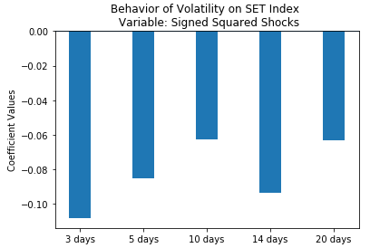

Figure 5: Regression Coefficient of Future Volatility on Three Explanatory Variables

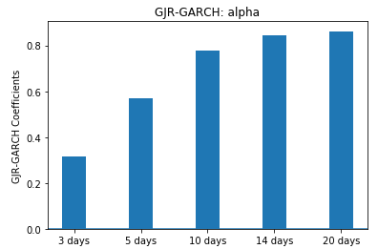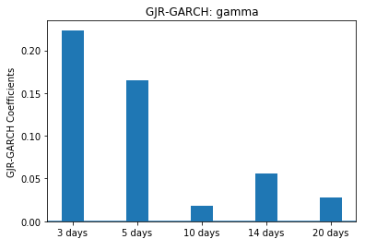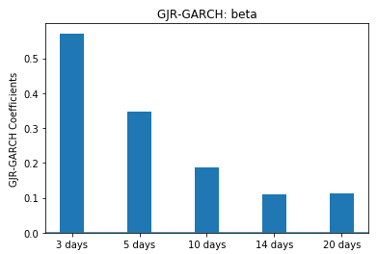

Figure 6: GJR-GARCH Coefficient of Future Volatility on Three Explanatory Variables

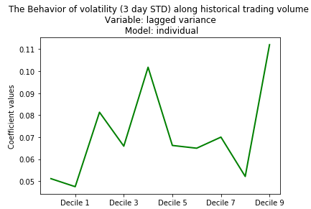 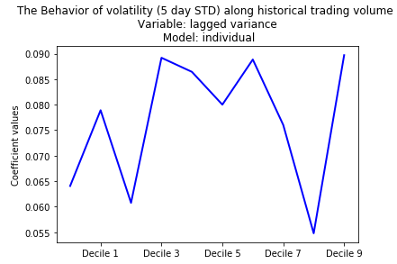

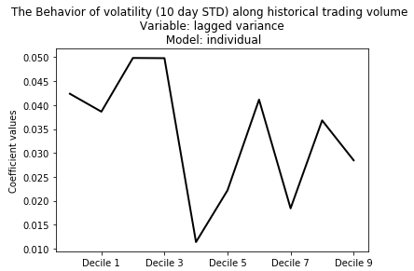 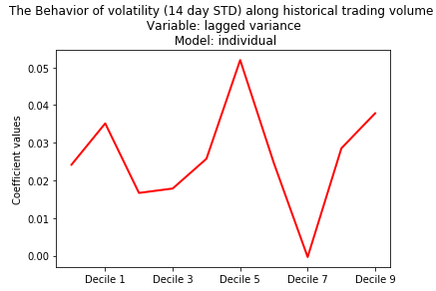

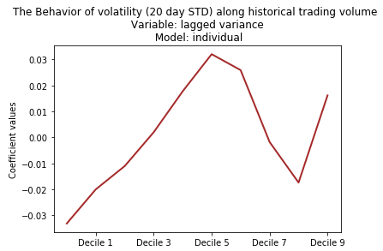

Figure 7: Regression Coefficient on Lagged Variance Along Historical Trading Volume

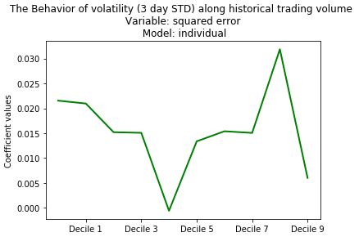 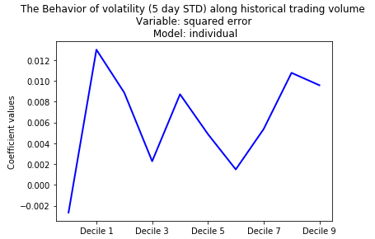

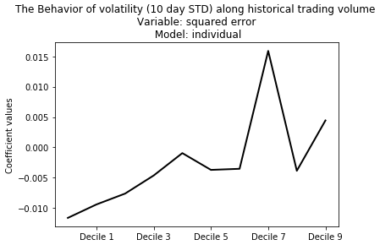 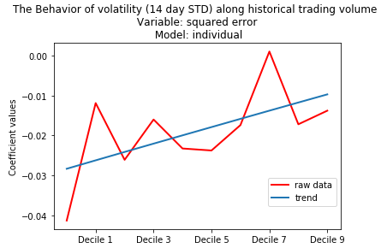

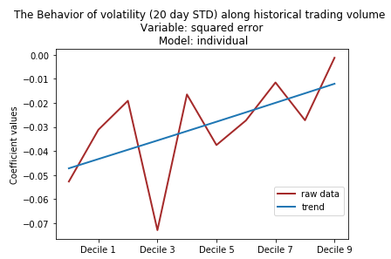

Figure 8: Regression Coefficient on Squared Error Along Historical Trading Volume

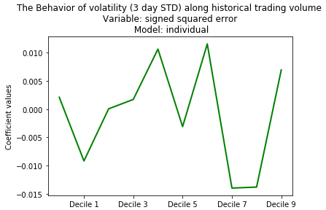 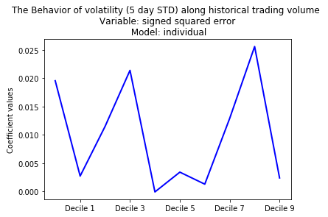

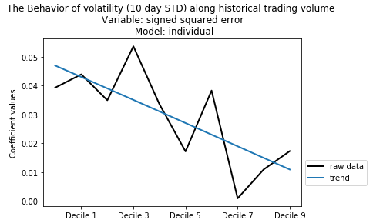 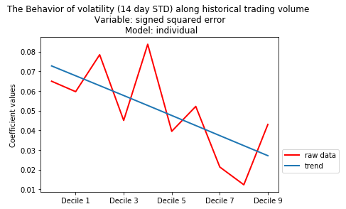

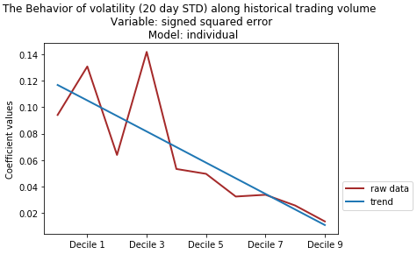

Figure 9: Regression Coefficient on Signed Squared Error Along Historical Trading Volume

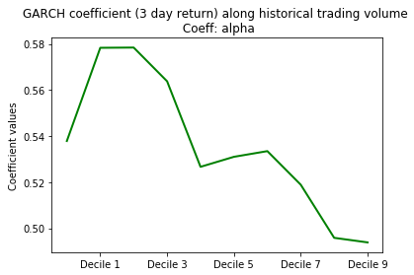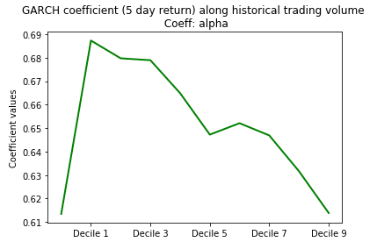1.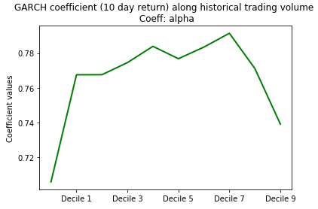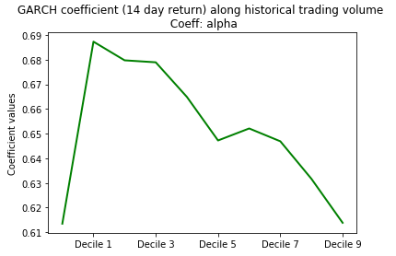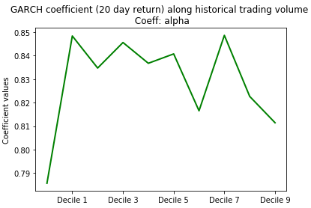

Figure 10: GJR-GARCH Coefficient on Shocks (alpha)

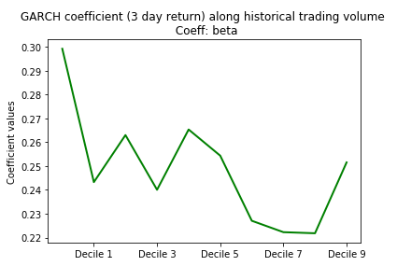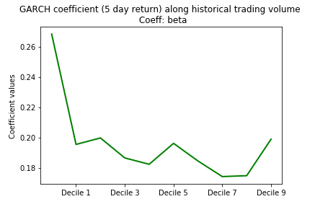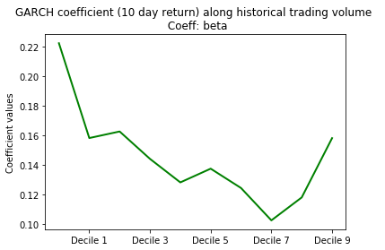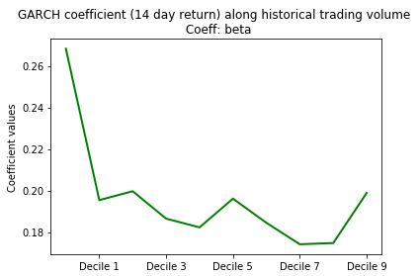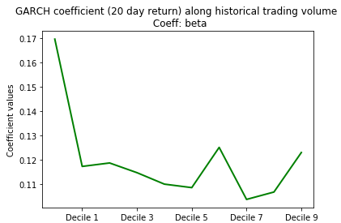

Figure 11: GJR-GARCH Coefficient on Volatility Clustering (beta)

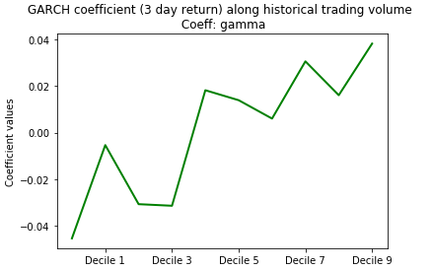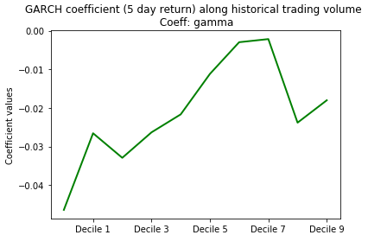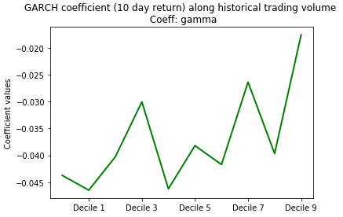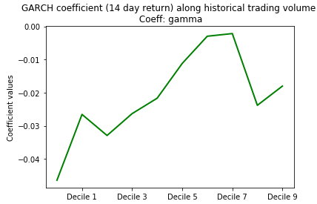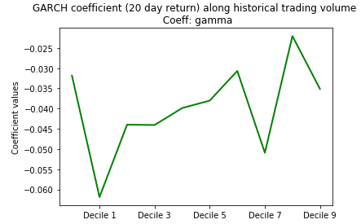

Figure 12: GJR-GARCH Coefficient on Negative Shocks (gamma)